UML Assignment:

1)uml class diagram to represent an airline reservation system:

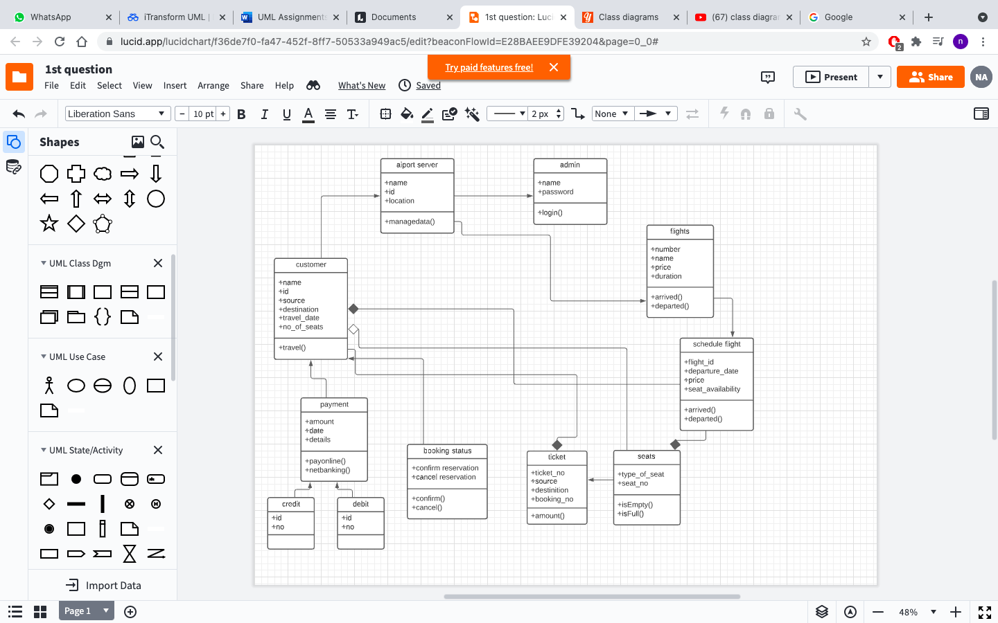

2) UML class diagram of university

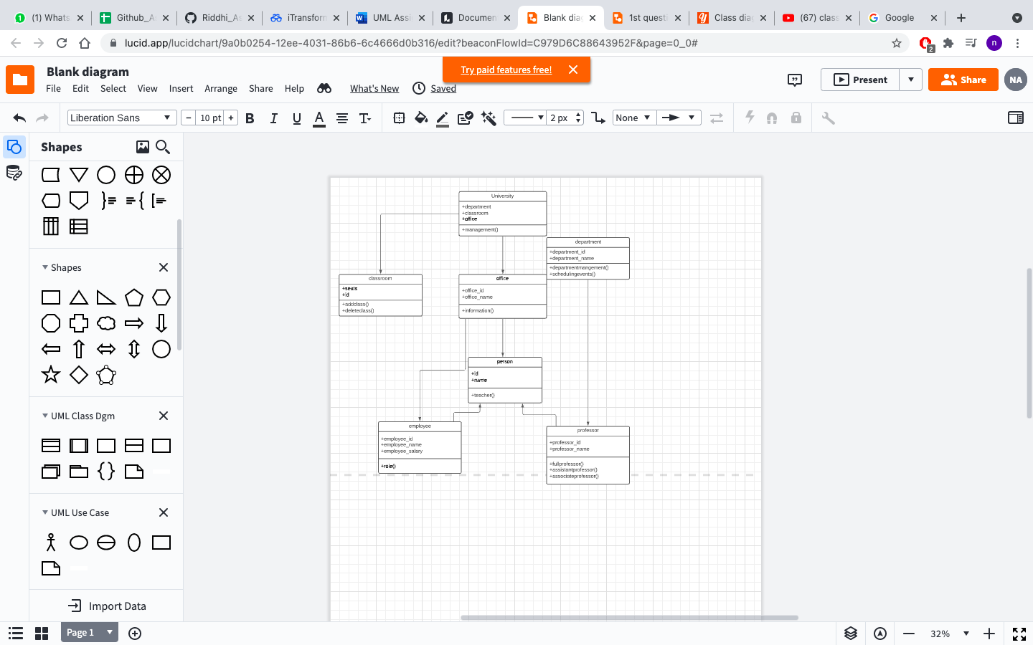

3) Activity diagram:

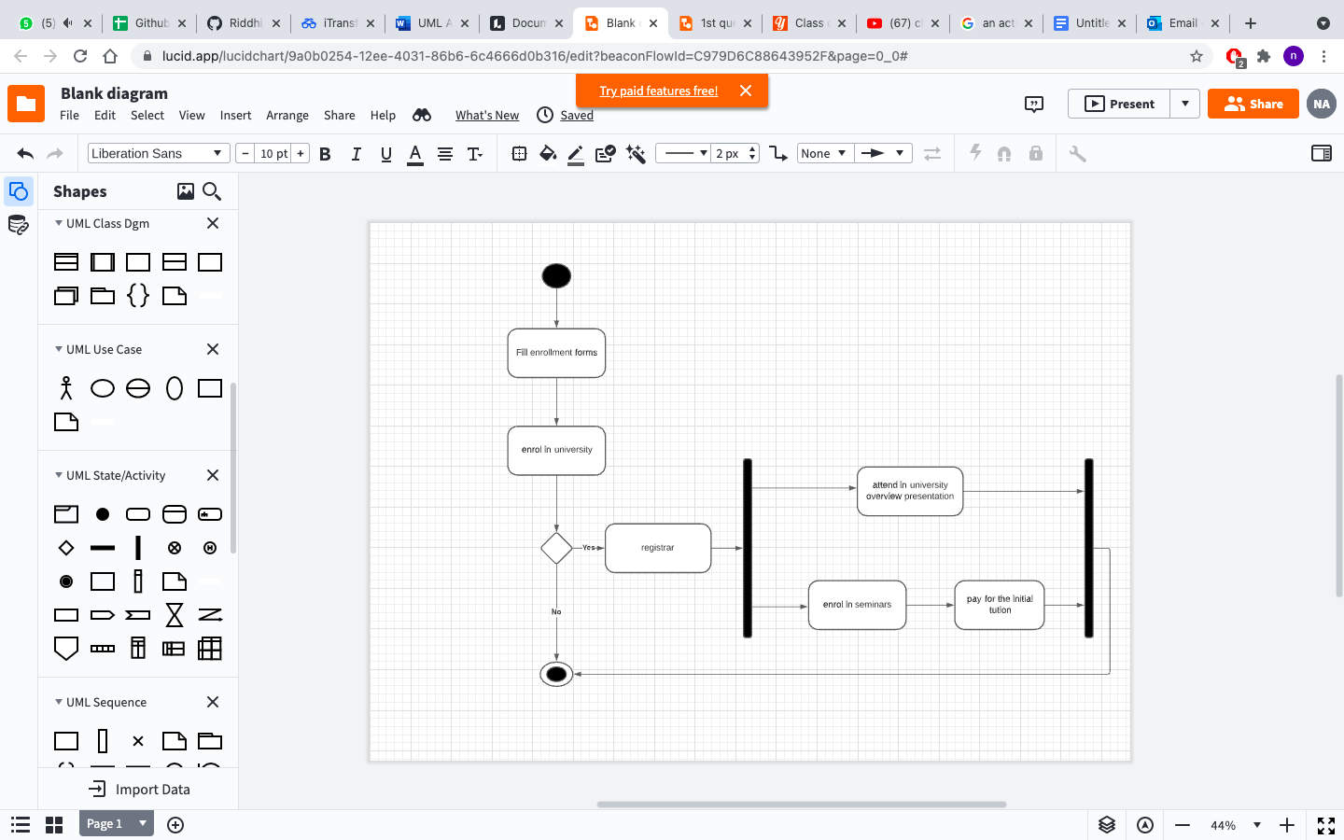

4) Sequence diagram for online library management system:

